# 1. Auto Trace & Explain Plan

## 1.1. Task 1: Auto Trace configuration training

**Task Results:**

Expected:

Summary table with all result and text description of analyses this results.

|  |  |  |  |
| --- | --- | --- | --- |
| № | Auto Trace Configuration Options | Expected Results | Description |
|  | set autotrace off; | Disables all autotrace | / == / |
|  | set autotrace on; | Shows the execution plan as well as statistics of the statement | / == / |
|  | set autotrace traceonly; | Displays the execution plan and the statistics (as set autotrace on does), but doesn’t print a query’s result | Might be useful while processing big queries |
|  |  |  |  |
|  | set autotrace on explain; | Displays the execution plan only | Only explain plan processing |
|  | set autotrace on statistics; | Displays the statistics only | Only statistics processing |
|  | set autotrace on explain statistics; | Displays execution plan as well statistics of the statement | The same as ‘set autotrace on’ |
|  |  |  |  |
|  | set autotrace traceonly explain; | Displays the execution plan only and doesn’t print a query’s result | The same as previous, but doesn’t provide a query’s result. Might be very useful while processing big data queries. |
|  | set autotrace traceonly statistics; | Displays the statistics only and doesn’t print a query’s result |
|  | set autotrace traceonly explain statistics; | Displays the execution plan as well the statistics and doesn’t provide a query’s result |
|  |  |  |  |
|  | set autotrace off explain; | Autotrace is optionaly disabled. | Doesn’t work as it expected. “Unwanted extra autotrace option: %option%” |
|  | set autotrace off statistics; |
|  | set autotrace off explain statistics; |

# 2. Join Methods

**The Main Task** is to create SQL and prepare execution plan of statements with join methods on Task Topics (Task 2 - 9)

**Task Results:**

There are several tasks below with the same main expected result points:

* Create SQL using next tables: scott.emp, scott.dept
* Create additional needed Tables and Indexes
* Prepare screenshots of execution plan

## 2.1. Task 2: Nested Loops Joins

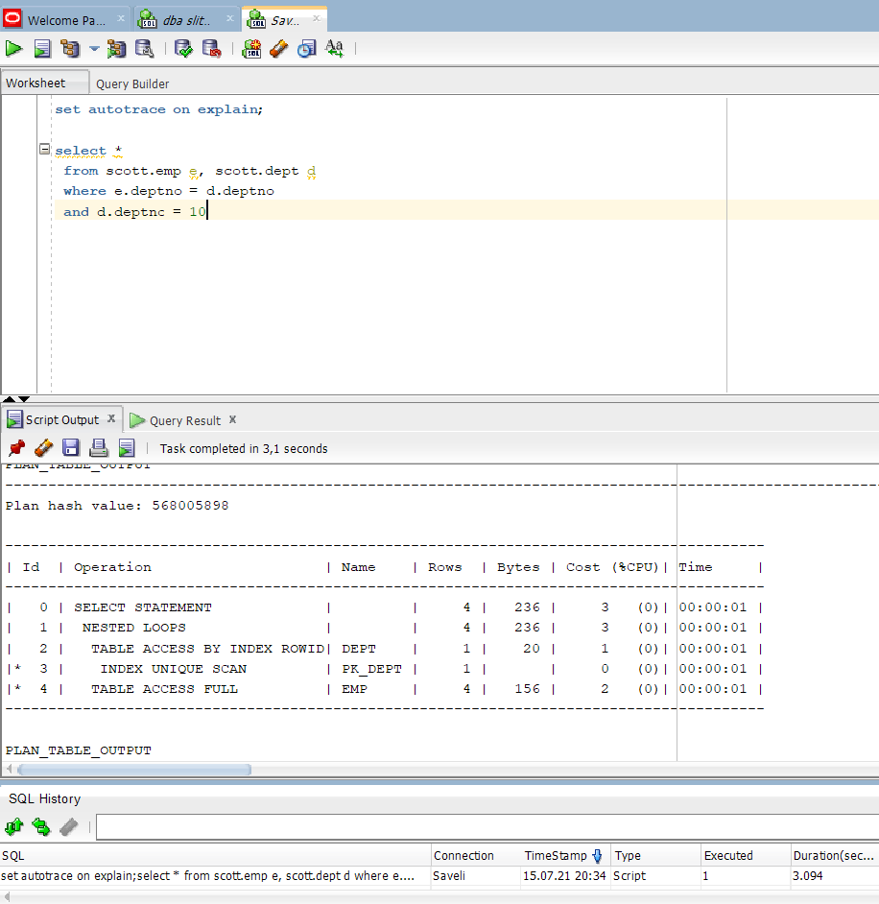

2.1 Nested Loop Join

## 2.2. Task 3: Sort-Merge Joins

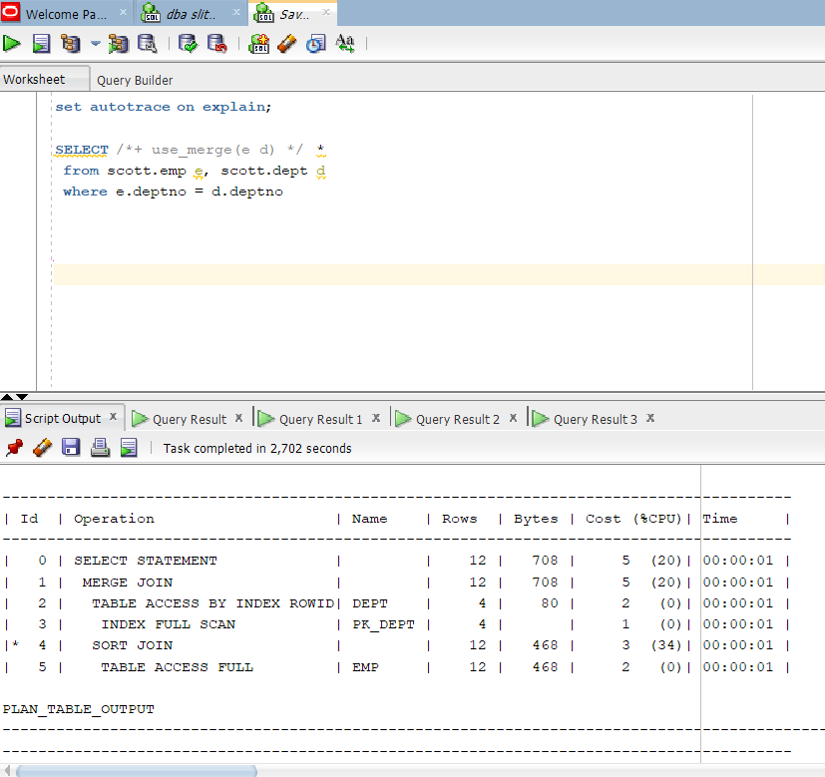

Sort Merge Join

## 2.3. Task 4: Hash Joins

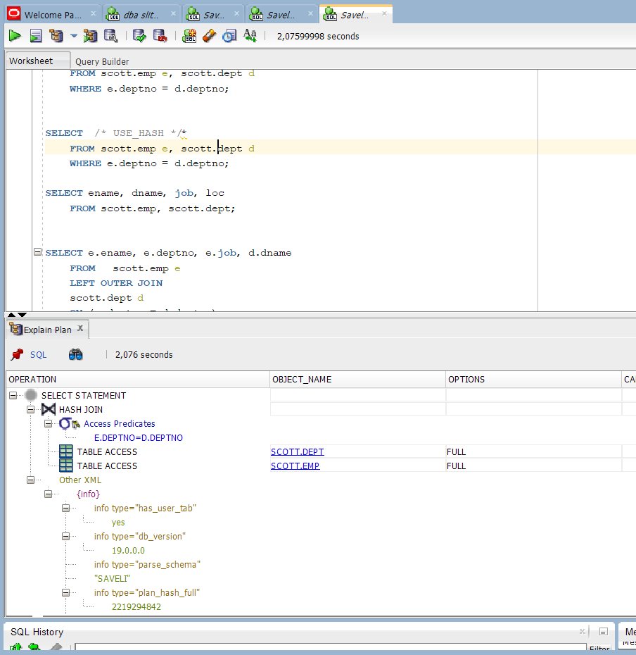

Hash join

## 2.4. Task 5: Cartesian Joins

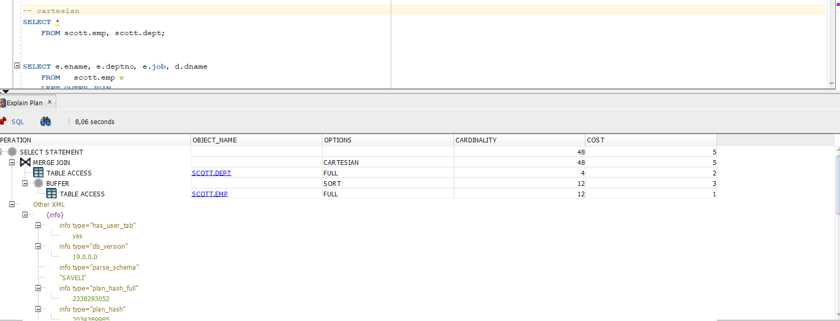

Cartesian Join

## 2.5. Task 6: Left/Right Outer Joins

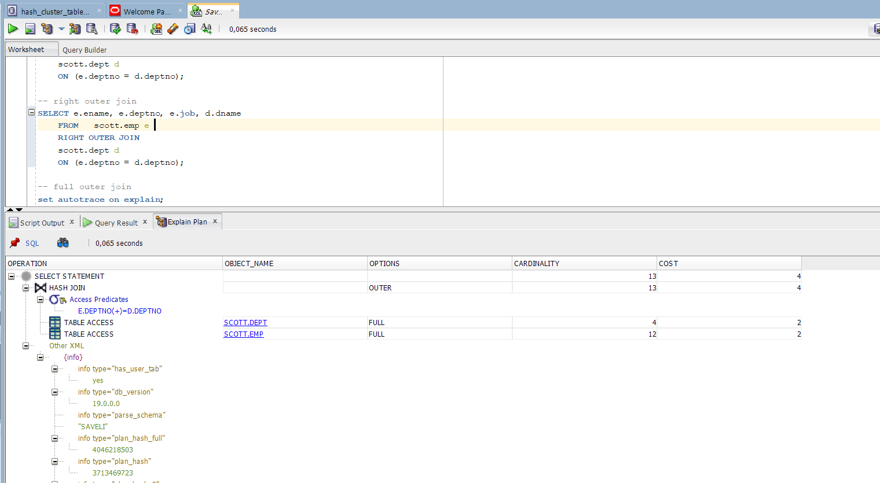

Right outer join

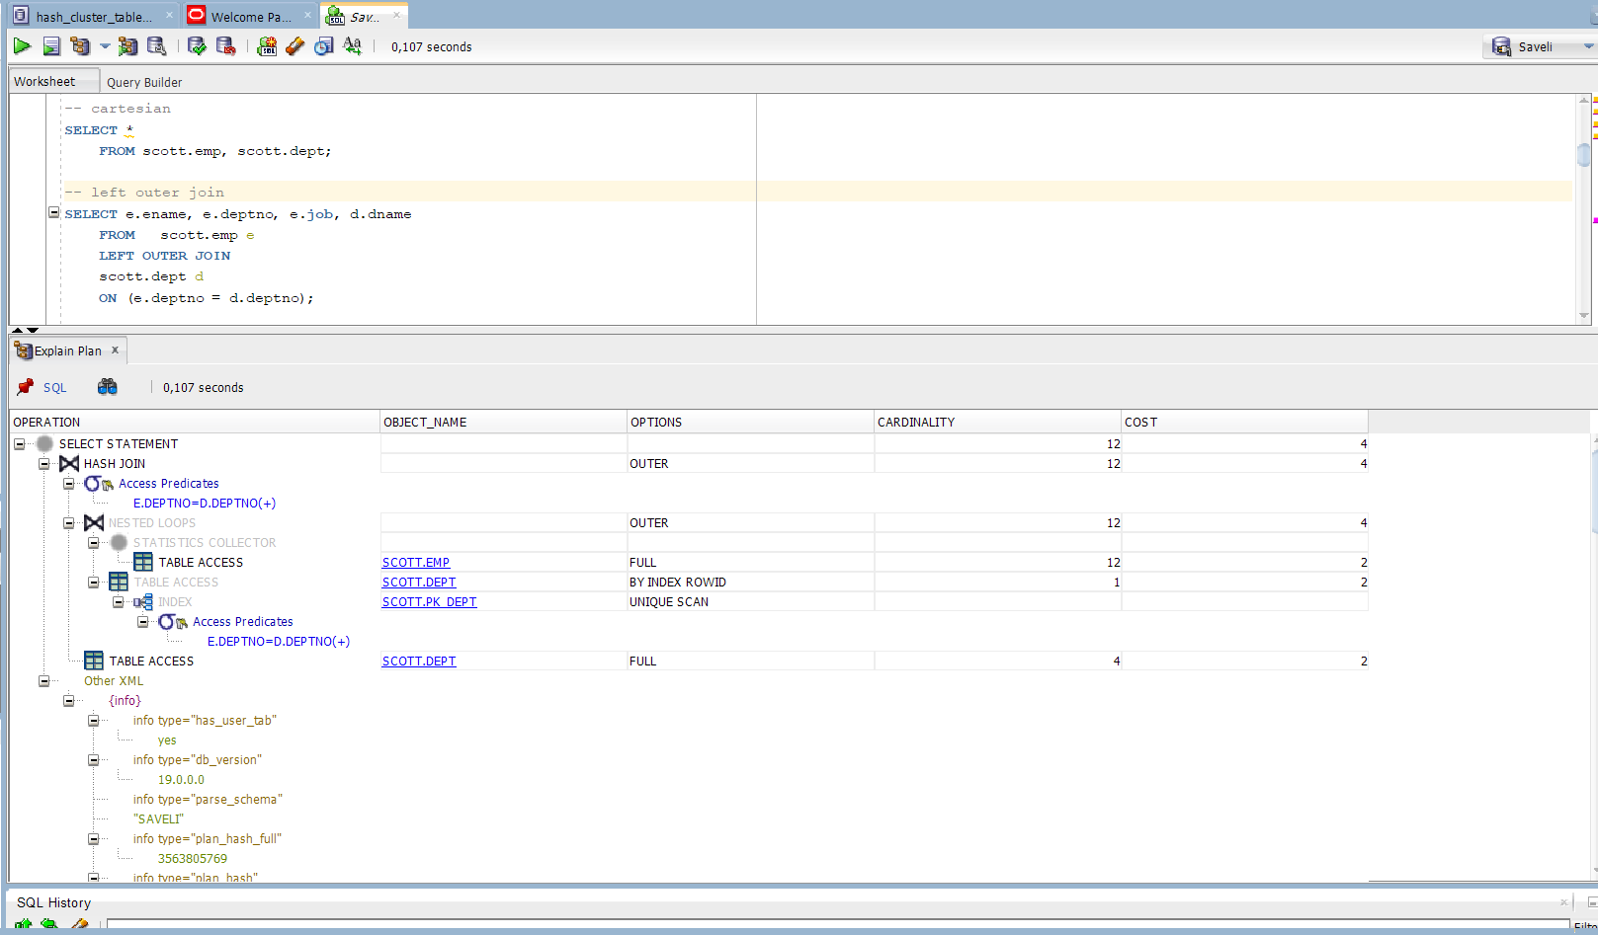

Left outer join

## 2.6. Task 7: Full Outer Join

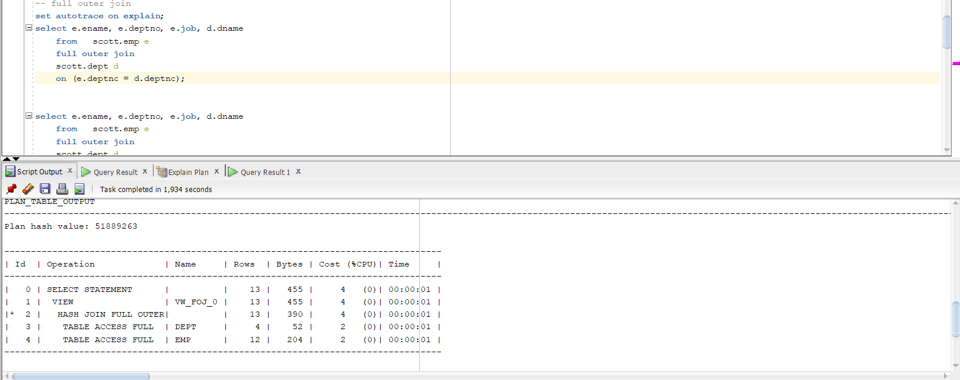

Full outer join

## 2.7. Task 8: Semi Joins

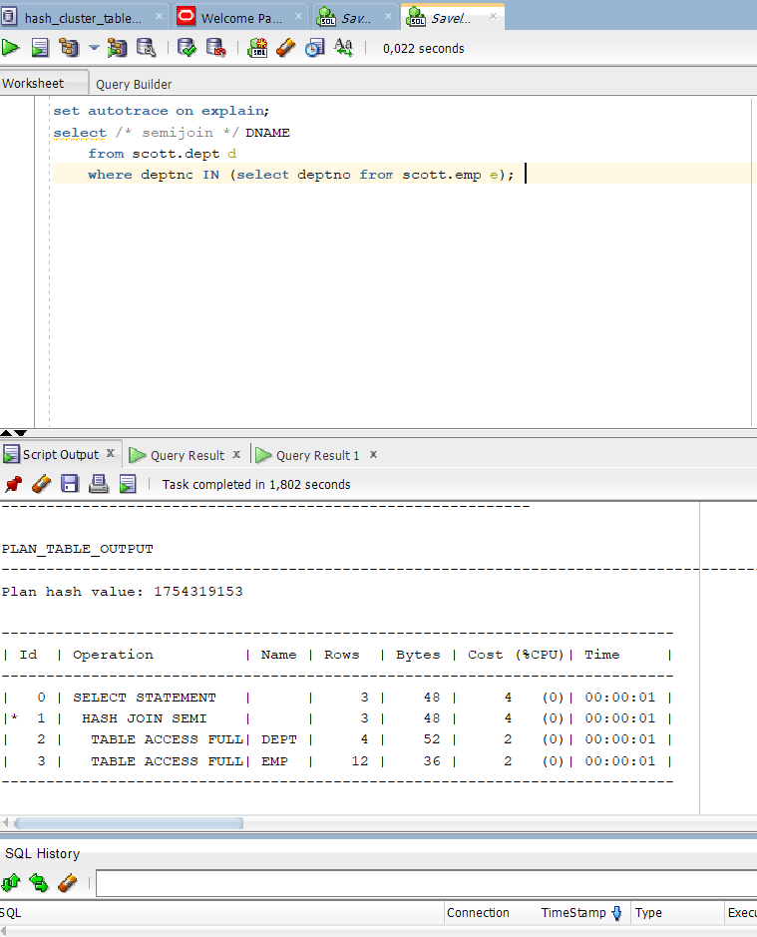

SemiJoin

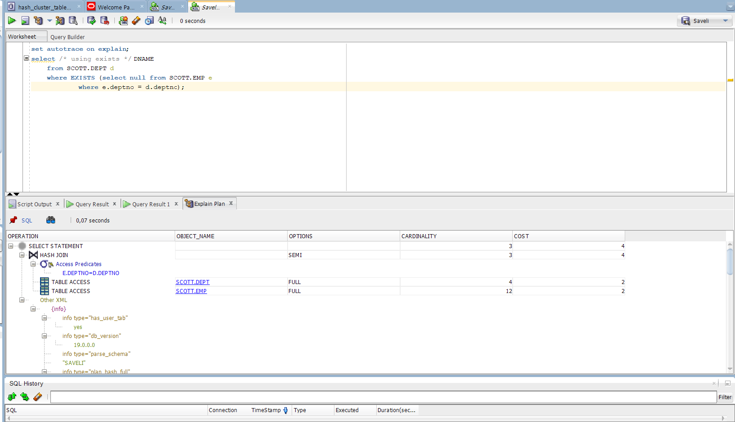

Using exists semijoin

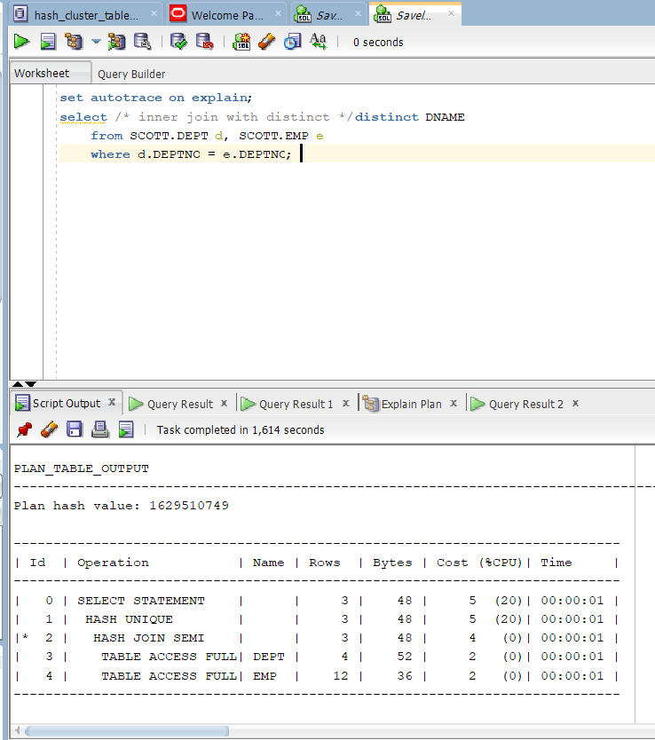

Unique semi join

## 2.8. Task 9: Anti Joins

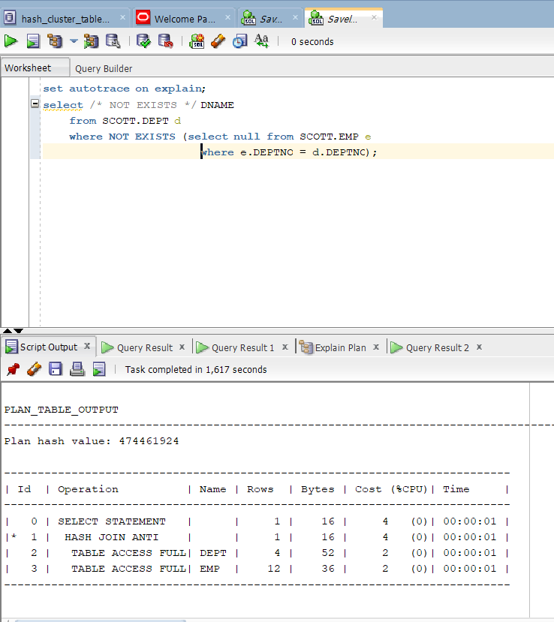

Not exists Anti Join

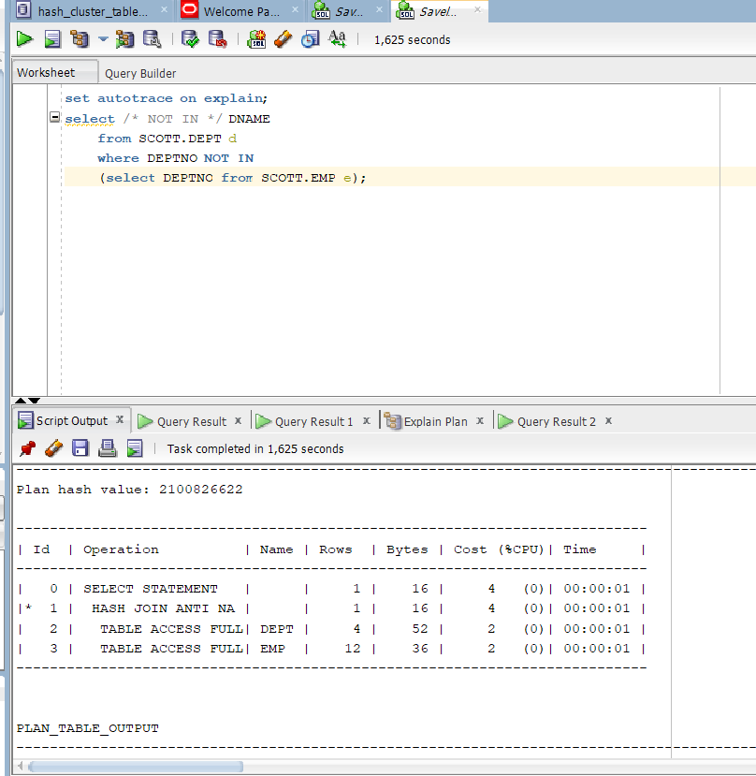

Not in Anti Join

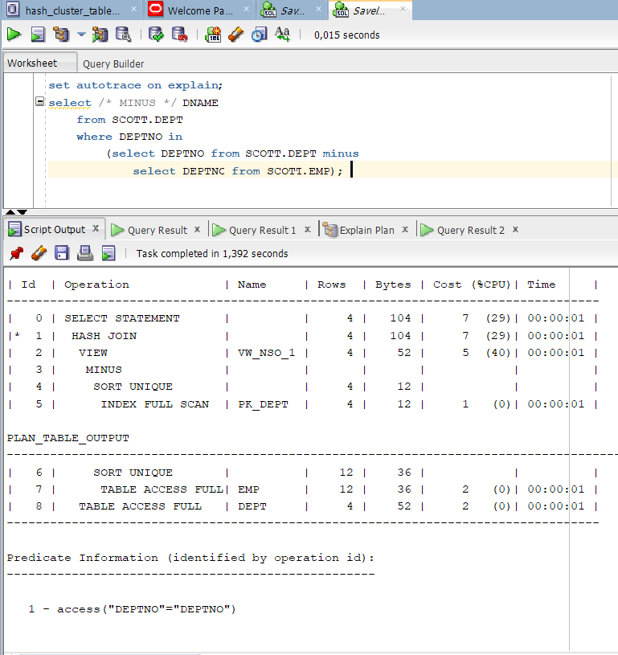

Minus anti join

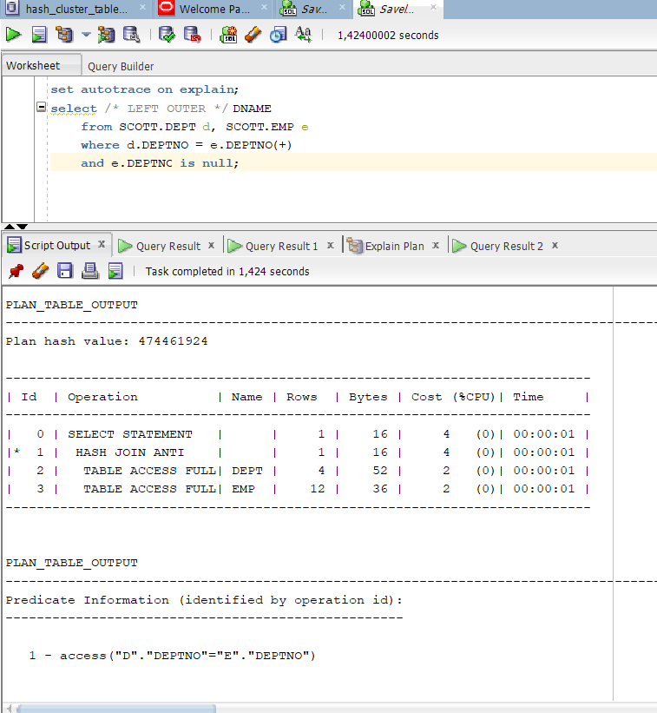

Left outer anti join

## 2.9. Task 10: Prepare summary table

|  |  |  |  |  |  |  |
| --- | --- | --- | --- | --- | --- | --- |
| Join Access “A” | Join Access “B” | Nested Loop | Hash Join | Sort-Merge Join | Anti-Join | Semi-Join |
| Small Table | Small Table | Perfect | Neutral | Neutral | Anti-Join and Semi-Join is situationable joins. Depent on current user needs they could be adapted for using. There’s no perfect or less bad strategy to use this type of joins. Actually use full goes through the users needs. | |
| Small Table | Indexed Small Table | Perfect | Neutral | Neutral |
| Indexed Small Table | Indexed Small Table | Perect | Neutral | Perfect |
| Big Table | Big Table | Bad | Perfect | Neutral |
| Big Table | Indexed Big Table | Bad | Perfect | Neutral |
| Indexed Big Table | Indexed Big Table | Bad | Perfect | Perfect |
| Small Table | Big Table | Bad | Perfect | Perfect |